**National University of Computer & Emerging Sciences, Karachi**

**Fall 2022**

**Restaurant ordering system**

|  |  |
| --- | --- |
| **Group Leader and ID:** | **Usman Rasheed 21K-3225** |
| **Member 1 and ID:** | **Syeda Fatima Ashraf 21K-3455** |

**Project Description:** The project is meant to emulate the system of a Restaurant’s food ordering system, and the program contains three types of menu system:

1. A Sign up Menu
2. A Login Menu
3. A Manager Menu

The Sign up menu allows the user to input a Customer into the Restaurants system.

The Login menu allows the user to first login into an already created account and then access functions such as ordering food, and changing their personal details. Once ordering food the user will be able to see the available food items present and then order accordingly to their wants, a receipt will be created in the end.

An Example of Ordering Food:

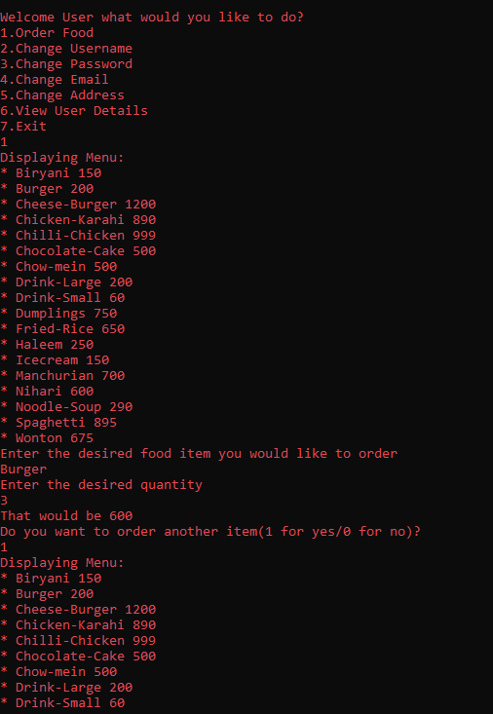

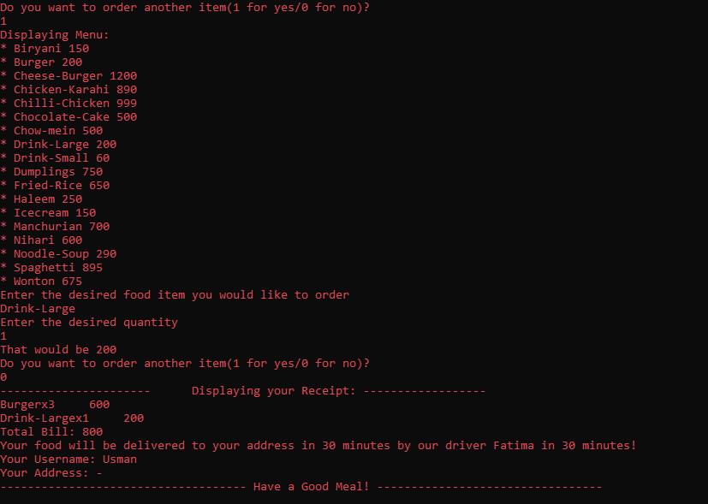

The Manager menu allows the Manager to view details of the customers, and food items present in the program and furthermore such as inserting more food items/Customers, and deleting the existing food items/Customers.

An example of the options available in the Manager Menu:

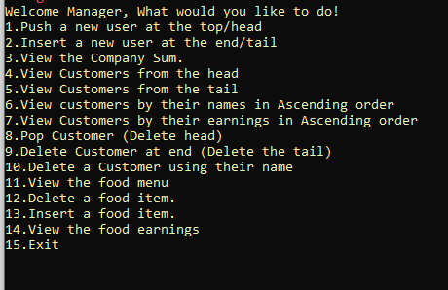

Both the food items, and the customers are different types of nodes. The food items nodes together create a Binary Search Tree, while the customer nodes together create a doubly linked list.

**Concepts of Data Structures used:**

1. Linked List
2. Binary Search Tree
3. Recursion/Backtracking
4. Use of Queues
5. Use of Stacks in linked list (Although indirectly)
6. Sorting
7. Searching in both BST, and Linked Lists

**Concepts of Object Oriented Programming used:**

1. Use of classes
2. Inheritance
3. Function Overwriting

The inheritance Diagram is as follows:

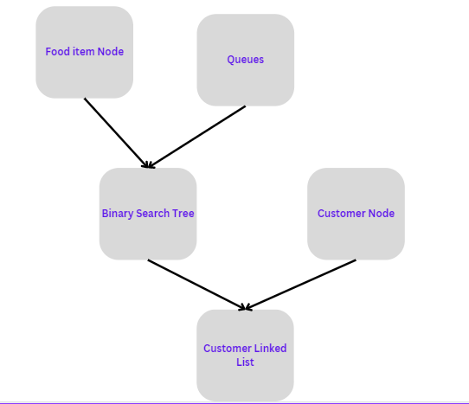

**Concepts of Programming Fundamentals used:**

1. Conditional Statements
2. Use of Loops, and nested loops
3. Use of structs
4. Filing
5. Use of /rand